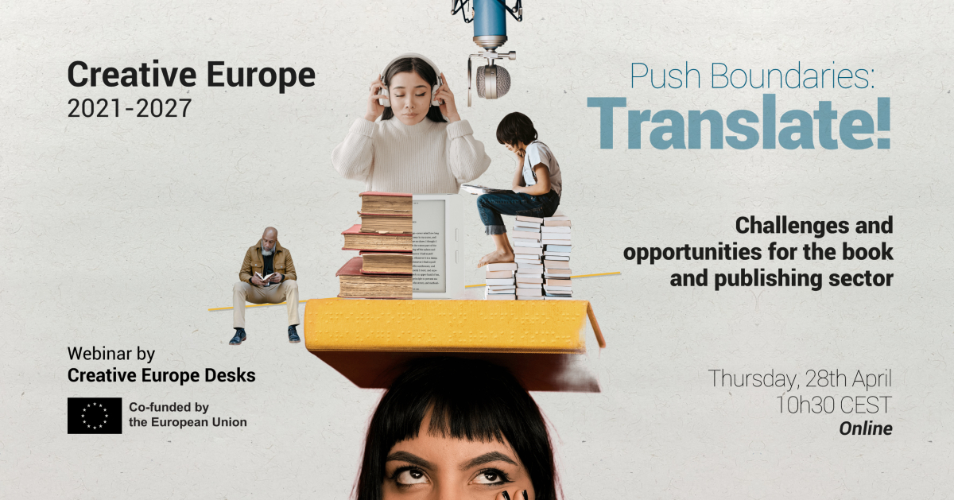
In the framework of the currently open call for projects Circulation of European Literary Works, the Creative Europe Desks are teaming up to organize a webinar dedicated to the challenges and opportunities for the book and publishing sector:
Push Boundaries: Translate !
Thursday 28th April 2022 / 10.30 CEST
How to make European fiction cross-borders? How to tackle the needs of the book sector in terms of internationalisation? How to assure that translation becomes a means of bridging linguistic barriers and foster access to cultural diversity, while guaranteeing fair remuneration for authors and translators?
To answer these questions, we will look into the opportunities for the sector in the framework of the new Creative Europe programme 2021-2027, with a focus on the dedicated sectorial call, together with representatives of the European Education and Culture Executive Agency (EACEA). The programme manager of the book sector at the European Commission will give an essential update on the policy framework and the recently published OMC group report Translators on the Cover. And with invited experts we will look at the crucial needs for the sector in terms of internationalization.
Guest Speakers:
- Arnaud Pasquali, European Commission Programme Manager – Book sector
- Corinne Rigaud, European Education and Culture Executive Agency, Head of Sector – Creative Europe horizontal and sectorial actions, including book and publishing sector
- Arturo Peral, Literary Translator
- Polona Konjedic, European Education and Culture Executive Agency
- Tara Lennert, Journalist, literary consultant and evaluator of the call for Circulation of European Literary Works Projects
Programme

10.30 am Welcome & introduction
Opportunities for the book and publishing sector in the Creative Europe 2021-2027 programme: A brief overview
10.50 am European policy & challenges for the book and publishing sector
Arnaud Pasquali, European Commission Book Sector Programme Manager; Arturo Peral, Literary translator and Polona Konjedic, European Education and Culture Executive Agency (EACEA)
- “Translators on the cover”: Presentation of the OMC report and policy update
- Tackling the challenges for the circulation of books beyond borders
11.30 am Support to the Circulation of European Literary Works
Corinne Rigaud, EACEA Head of Sector, Yoana Stefanova, EACEA Project Manager and Tara Lennart, Journalist, literary consultant and evaluator of the call for Circulation of European Literary Works Projects
- Presentation of the call Circulation of European Literary Works Projects,
- What are the keys to a good project proposal?
12.15 pm Q&A and Closing remarks

Link for registration here.
This webinar is a joint initiative of Creative Europe Desks from Belgium, Denmark, Italy, Luxembourg, Portugal, and The Netherlands.

