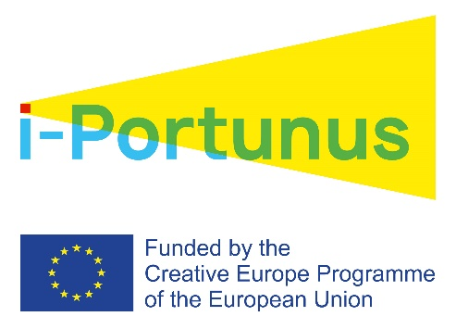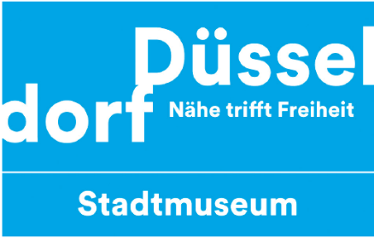

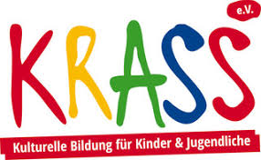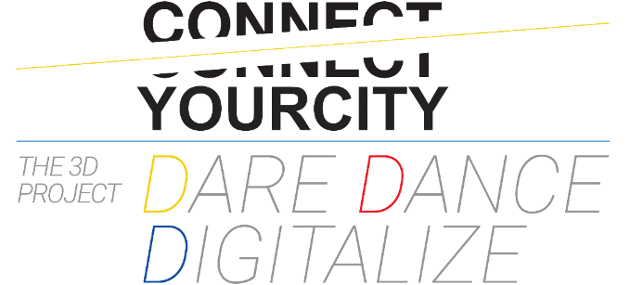

A DREAMY DIALOGUE BETWEEN ATHENS & DUSSELDORF

CONNECT YOUR CITY was established in order to connect people! During November 2019, CONNECT YOUR CITY managed to connect two cities (Athens & Dusseldorf), through it’s innovative interdisciplinary artistic project ‘’The 3D Project- Dare Dance Digitalize’’. Dancetheatre, non violent communication and digital technology are the basic tools of the project, in addition with the most important technology we own: Our Human bodies and our psychology.
This project was funded to be implemented in Dusseldorf for 18 days. It was selected as one of the 30 from a total of 700 applications from artistic teams from all over Europe, in the frame of the second round of the European program ‘’i-portunus creative europe mobility project’’ with the funding of Goethe Institut in Munchen. It is a co-production of Connect your city youth center in Athens, Stadtmuseum Dusseldorf (one of the biggest city museums of Europe) and KRASS Dusseldorf organization, in which artists offer artistic labs to children and youngsters of vulnerable social groups.
From 2/11 until 15/11, there was a ‘’performative work in progress’’ in the collections room of the museum, that led to the final performance in the same space, on 16/11 with the german title ‘’Traum-clip’’ that means ‘’Dream-clip’’.
Antonis Bertos, founder and director of the project, worked with professional performers and dancers from Greece and Germany (Nikos Karapanagos, Artemis Manakou, Anna Kempin, Tasi Halle) and created a dreamy atmospheric performance inside the museum. The director writes: ‘’ Dream-clip was designed to research the limits between real life and dreams. Our lives are a continuous negotiation between what really happens and what could possibly happen in the future. In our everyday life, sometimes is like living in two parallel worlds-the real world and the dreamworld consisting of our thoughts and our dreams. Only through this process we can reach our deeper levels of substance.
The above relationship between real life and dreams was researched through the following means: The interaction of performers-dancers (as ‘’live-bodies exhibits’’) with the exhibits of the museum (paintings-photographies), in addition with the use of video as an exhibit also, consisting of three different types of videos: videodance (repetition of some parts of the live performance in the museum, but video recorded from a different angle/frame), road-trip video and stop motion.
All the above visual and performative research was made with the aim that the audience can take a pause and see the other (we usually bypass and overlook the ‘’others’’ especially those who look different and tend to be invisible for us because we sometimes refuse to see them). It’s high time we saw the dreams of each other, either in the space of a museum, or in the difficult space o a refugee camp or in the space of a school. With this process, may the communication will be improved between different social groups. Under this frame of the project, workshops of creating dream videos were given in the refugee camp ''Meineckestrasse camp'' and the Greek Lyceum of Dusseldorf.

‘‘The 3D Project- Dare Dance Digitalize’’ started on January 2019. During 2019, four performances have been given (Centre of Athens/ Leipzig/ European music Day-Varnava Square-Pagrati-Athens/ Dusseldorf) in which 14 artists (dancers and musicians), 70 youngsters 16-30 years old and 14 youngsters from vulnerable social groups. The audience reached up to 500 people in Greece and Germany.
The vision and the aim of the project for the forthcoming years is to unite more cities, people, different social groups and organizations through dreamy artistic dialogues that will bring versatile groups in Greece and Germany together, in an era where the challenges are huge. The answer to these challenges should contain more art-communication-inclusion and more passion for life.

Information:
Connect your city youth center (Patision 68 και Kotsika 2, Victoria Square-Athens-1st floor,
tel 2108210520)
Founder & responsible of the 3d project: Antonis Bertos 6981780402
For further information, please click on link below for the official facebook page of the project
FB: https://www.facebook.com/pg/DARE-DANCE-Digitalize-The-3D-project-2212307105518892/posts/?ref=page_internal

About Connect your City
The program CONNECT YOUR CITY, runs as a program of IASIS Ngo and it’s created to cover the needs of young people between 16 and 30 years old in an era where the need of supporting the young people of the new generation is more crucial than ever before.
CONNECT YOUR CITY aims at motivating youngsters in active citizenship through psychological and social support, sport activities and educational projects that have been designed by young people for young people (peer to peer learning). Our approach is holistic and our organization intervenes in every part needed with the final aim to be the beginning of their job placement.

For further information for our services, please visit our website: http://www.iasismed.eu/

